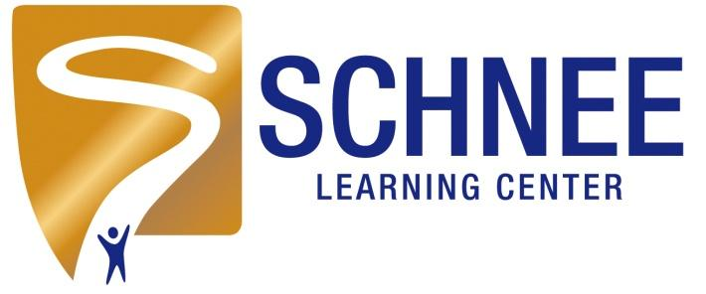
800 Tallmadge Rd.
Cuyahoga Falls, Ohio 44221
Phone: 330.922.1966
Fax: 330.945.4059

Date: August 2026

RE: Every Student Succeeds Act (Public Law 114-95), Section 1112 (e)(1)(A)

Dear Parent/Guardian:

You have the right to know about the teaching qualifications of your child’s classroom teacher in a school receiving Title I funds. The federal Every Student Succeeds Act (ESSA) requires that any school district receiving Title I funds must notify parents of each student attending any school receiving Title I funds that they may request, and the district will provide the parents on
request (and in a timely manner), information regarding the professional qualifications of the student’s classroom teachers, including at a minimum, the following:

• Whether the teacher has met State qualification and licensing criteria for the grade levels and subject areas in which the teacher provides instruction.

• Whether the teacher is teaching under emergency or other provisional status through which State qualification or licensing criteria have been waived; and

• Whether the teacher is teaching in the field of discipline of the certification of the teacher.

• Whether the child is provided services by paraprofessionals and, if so, their
qualifications.

You may ask for the information by returning this letter to the address listed above or you may e-mail your request. Be sure to give the following information with your request:
procedure is different, list it here.

Child’s full name
___________________________________________________

Parent/guardian full name
Address
___________________________________________________

__________________________________________________
City, state, ZIP
__________________________________________________
Teacher’s name
__________________________________________________

Sincerely,

Tony Pallija

Tony Pallija
Executive Director, Schnee Learning Center

